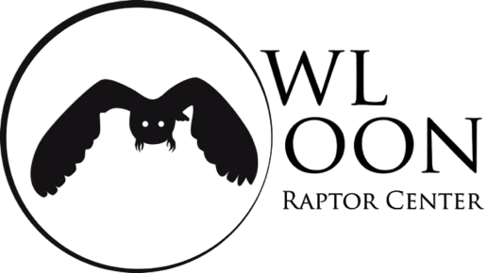
October 6, 2026

Founded in 2002, Owl Moon Raptor Center is a state and federally licensed wildlife rehabilitation center specializing in birds of prey. Our mission is to rescue and rehabilitate injured, sick, and orphaned birds of prey and return them to the wild in sound, athletic condition, and to educate the public about raptors in the process. Owl Moon is located in Boyds, Maryland and serves the entire state of Maryland.
Over the years, Owl Moon has treated hundreds of Osprey that have come in sick or injured. Typically, young Osprey are admitted to Owl Moon after encountering trouble while learning to fly. Returning a nestling to its nest, or placing it in a foster nest after injuries are treated, was common and largely successful. However, beginning three summers ago in 2023, an alarming number of juvenile Osprey were admitted suffering from starvation. In 2024, the number of Osprey admissions doubled, going from 48 in 2023, to 93 in 2024, with 66% of the juveniles in emaciated body condition. Many of these juveniles were extremely lethargic and weak, often dying within 24 hours of admission. Many others died after 3-4 days, suffering from refeeding syndrome.
In 2025 and 2026, Osprey admissions declined overall, with an unusually low number of juveniles admitted. Based on calls received and outreach to on-the-ground scientists, we believe many juveniles unfortunately died while still in the nest, without ever making it into care and rehabilitation, and survival rate of those admitted to Owl Moon was low.
A recent study from the William and Mary Center for Conservation Biology noted that 2026 was the worst Osprey season they have ever documented. Our numbers this summer are consistent with those findings. Juveniles made up almost half of the total patients and of those juveniles, 70% were emaciated.
It is clear from our perspective at Owl Moon that the Osprey population in the Chesapeake Bay is crashing. Juveniles are either dying in the wild or soon after they arrive for care. They are too weak from malnutrition to survive. Osprey depend on menhaden after returning from South America, to prepare for the breeding season. Once chicks have hatched, menhaden become critically important to their growth and survival. It is clear from the Center for Conservation Biology’s report that those Osprey depending on menhaden as a primary food source are unable to properly feed their young, and as a result nest failure is dramatically increasing not only in the Chesapeake Bay, but also along the east coast. This is a crisis, and immediate measures must be taken now.
The proposed Addendum by the Atlantic States Marine Fisheries Commission, to reduce and reschedule industrial menhaden fishing in the Chesapeake Bay, is necessary now. The Chesapeake Bay menhaden fishery cap should be reduced to zero, to properly address the crisis happening now in the Bay. In addition, creating quota periods would distribute the menhaden harvest throughout the fishing season and allow more opportunities for Osprey to have access to menhaden in critical ecological periods such as nesting and fledgling seasons.
The Chesapeake Bay is home to the largest population of Osprey in the world. There is consensus that the population is in serious decline. Now is not the time to simply fund more studies or make a less-than-meaningful cut to the cap. If strong action is not taken now, scientists predict the population could decline by half in the next 10 years. We no longer have time to wait.

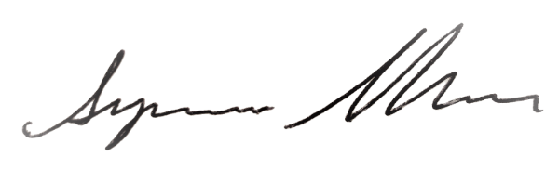
Suzanne Shoemaker
Executive Director & Founder
Owl Moon Raptor Center

